1. The diagram shows two identical shapes, A and B.
Name = Stephen Centre Number = 23215
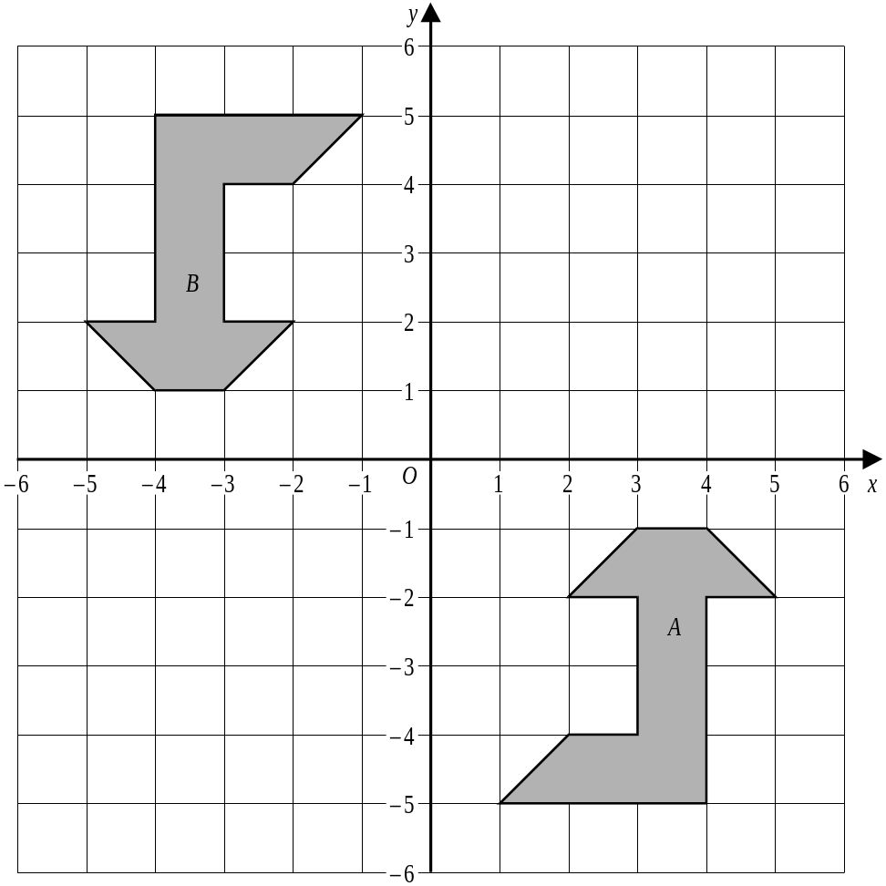
Describe fully the single transformation which takes shape A to shape B.
180° Rotation.
..............................................................................................................................................
..............................................................................................................................................
..............................................................................................................................................
(Total 3 marks)

Is Stephen correct?
Yes
No
Reason why?
…………………………………………………………………………………………………………….
…………………………………………………………………………………………………………….
…………………………………………………………………………………………………………….
…………………………………………………………………………………………………………….

2. Triangle A has vertices (1,2), (1,5) and (3,2).
6
5
4
3
2
1
–1
–2
–3
–4
–5
–6
–6
–5
–4
–3
–2
–1
O
1
2
3
4
5
6
x
y
A
New image
Draw the new position of triangle A after a rotation of 90° clockwise about the origin.
(Total 3 marks)

Is Stephen correct?
Yes
No
Reason why?
…………………………………………………………………………………………………………….
…………………………………………………………………………………………………………….
…………………………………………………………………………………………………………….
…………………………………………………………………………………………………………….

3. On the grid below there are two shapes, A and B.
–4 –3 –2 –1 1 2 3 4 5 6 7 8
x
y
10
9
8
7
6
5
4
3
2
1

–1
–2
–3
–4
–5
O
A
B
(a) Describe fully the single transformation that takes shape A to shape B
Rotation about (2,1)
.....................................................................................................................................
.....................................................................................................................................
(3)
Is Stephen correct?
Yes
No
Reason why?
…………………………………………………………………………………………………………….
…………………………………………………………………………………………………………….
…………………………………………………………………………………………………………….
…………………………………………………………………………………………………………….

4. The diagram shows a shaded flag.
x
y
–6
–5
–4
–3
–2
–1
1
2
3
4
5
6
6
5
4
3
2
1
–1
–2
–3
–4
–5
–6
O
A
Y=1
B
C
(a) Rotate the shaded flag 90° anticlockwise about the origin.
Label this new flag with the letter A.
(3)
(b) Reflect the original shaded flag in the line y = 1.
Label this new flag with the letter B.
(2)
(c) Rotate the original shaded flag by a quarter-turn clockwise about (0, 2).
Label this new flag with the letter C.
(2)
(Total 7 marks)

Is Stephen correct?
Yes
No
Reason why?
…………………………………………………………………………………………………………….
…………………………………………………………………………………………………………….
…………………………………………………………………………………………………………….

